[E102] Boil pump

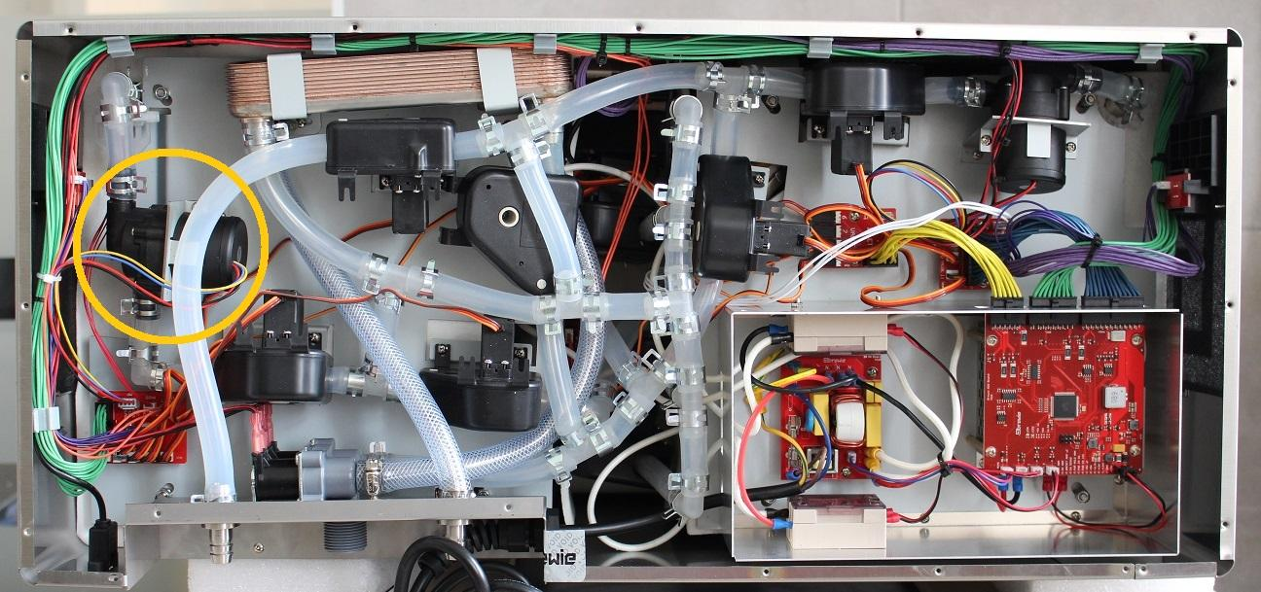

*Figure 1 Location of the boil pump in the B+*

Pull off the pipe clamp from the encircled fitting and bend back the silicone pipe from the fitting.

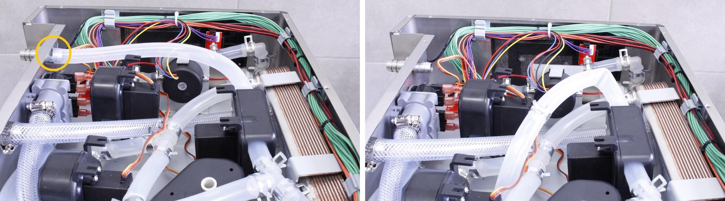

Unscrew the screws of the pump and remove the fastening clamp.

Pull off the pipe clamps from the pump fittings and pull off the silicone hose from the fitting.

Disconnect the pump cable from the PCB.

The pump is removable now.

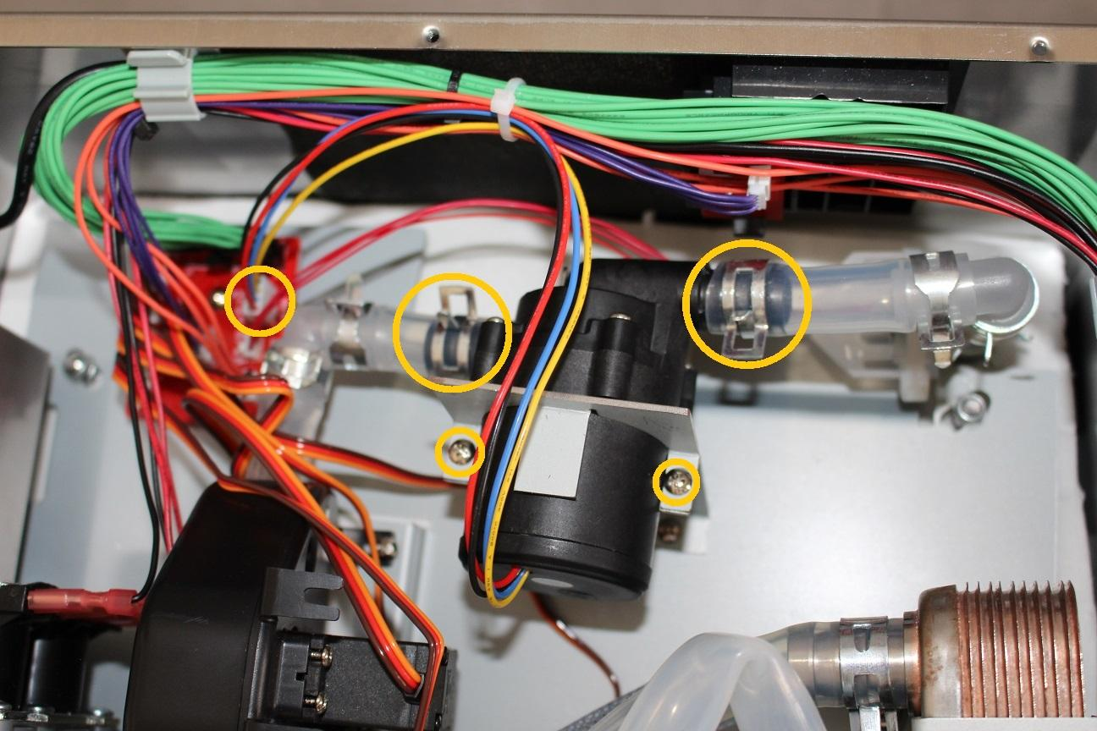

*Figure 2 Boil pump*

The pump is removable now.

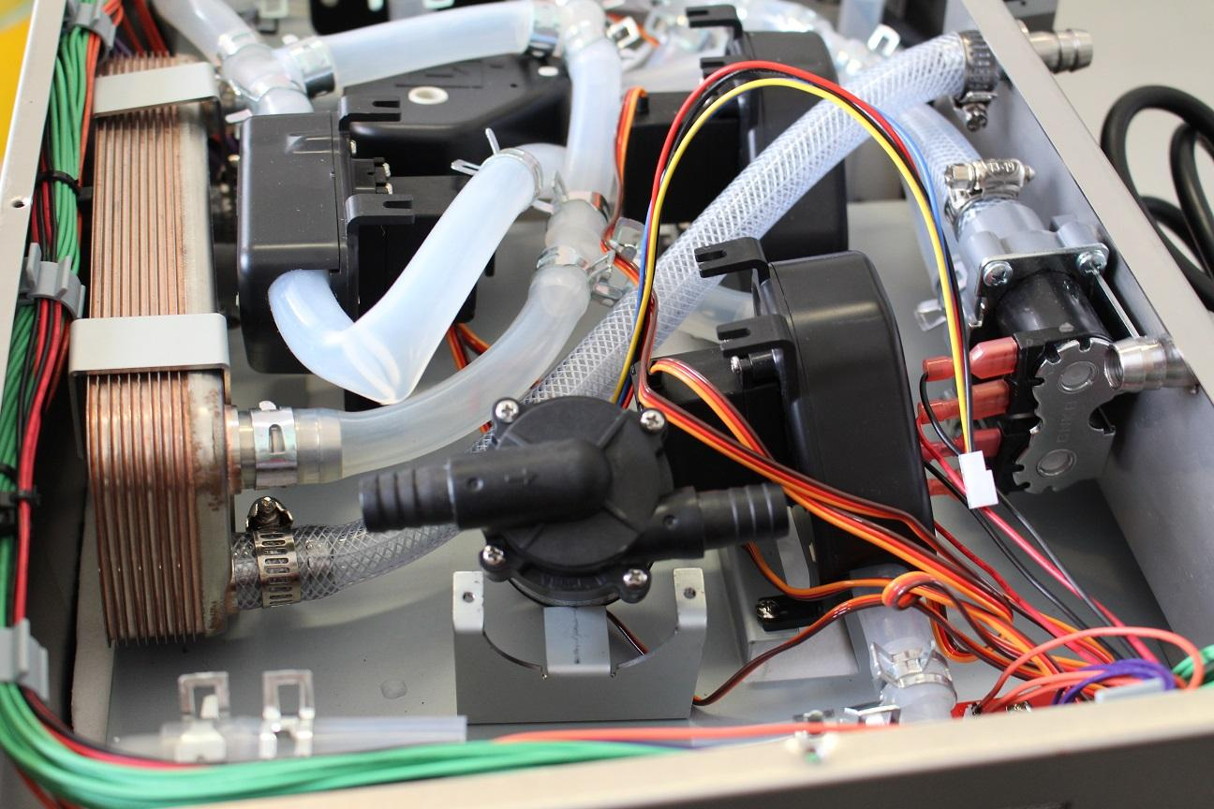

**IMPORTANT: In all cases you check if the pumps are clogged. If the pump is clogged, replacement is not necessary, after cleaning the pump can be used.**

Reassemble consists of the same steps in reverse.

While reassembling, take care that:

Make sure that the pumps are in the specified angle (check if during servicing the holding metal sheet wasn’t bent) and the marked direction of the flow is appropriate. In normal operation the device pumps the water OUT of the boil tank.

Make sure that the wort outlet hose clamp is in the proper angle. Otherwise you cannot reassemble the lower sheetmetal.

